A

Synopsis Report

On

Design of led cube using arduino


(2014-2018)

LED CUbe

Abstract
LED Cube as the name suggests, is a structure comprising of LEDs arranged as elements of a 3 dimensional matrix, hence forming a cube. In our case the matrix is of the order 4x4x4 i.e. there are 64 LEDs used in this structure. The project as we have developed it to be, involved controlling the illumination of different sets of LEDs so as to create patterns in the cube. This was achieved with help of Arduino Board. The LEDs are controlled using the programmable pins in Arduino.

Introduction
This Led Cube contains in total 64 LEDs. The LEDs are soldered together to form up a layer of 4x4 and 4 layers are soldered together to form a cube of 4x4x4. LED cube is divided into rows and column. Columns are connected in common cathode configuration and rows in common anode configuration. In other words, each column has a common ground and each row has common supply. Further to design, at least 20 wires are required. Four anode pins for powering up the cube and 16 cathode pins to control LEDs. Now to control a particular LED, a particular row is powered and a particular column is grounded. and to reduce the cathode pins further 4:16 decoder IC is used. This way only 4 pins are required. Disadvantage of this is that only one column can be controlled at a time. To overcome this programming plays an important role. The switching between the two column is done so fast that human eye cannot possible tell. Using the decoder IC makes the coding a bit difficult but at the same time because only one column is powered at a time so less power is drained out of the Arduino.

Components
- 64 LEDs
- Decoder IC 74154
- Arduino Mega (2560 )
- Zero PCB board
- Female Headers

Design of led cube

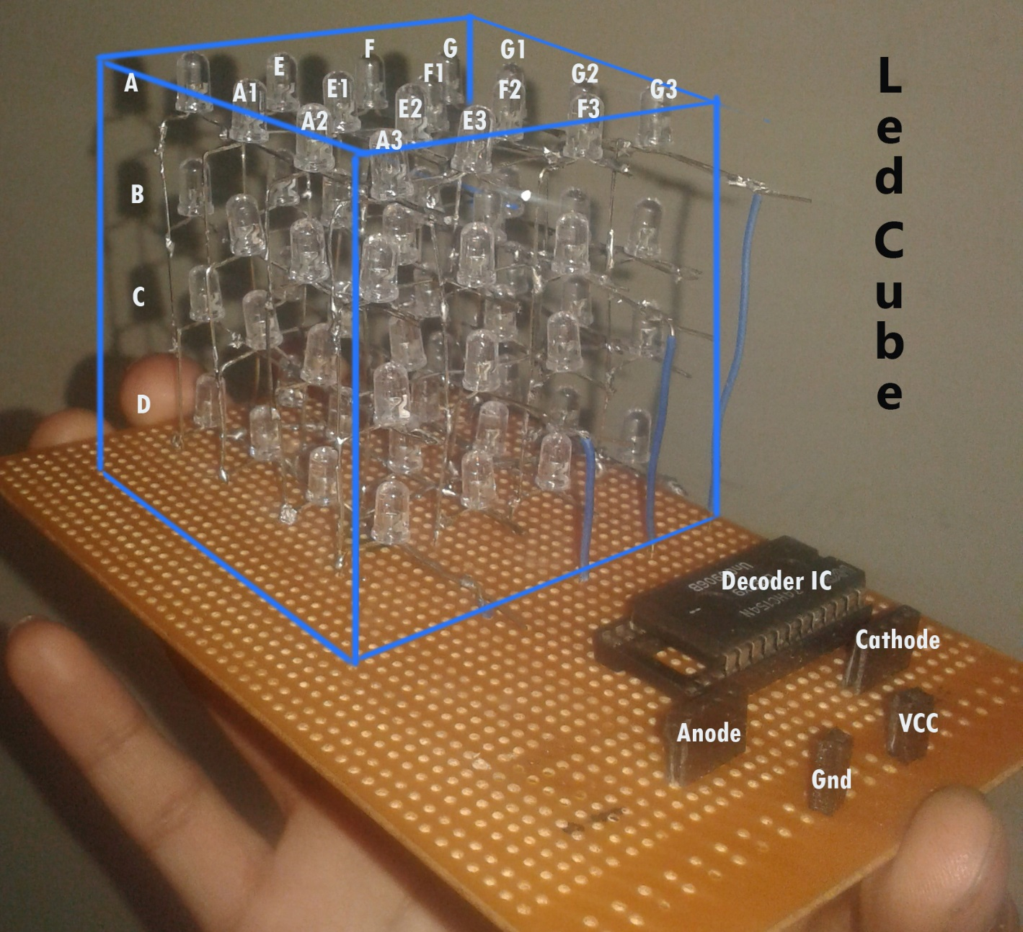

Truth Table
S0 | S1 | S2 | S3 | A0 | A1 | A2 | A3 | E0 | E1 | E2 | E3 | F0 | F1 | F2 | F3 | G0 | G1 | G2 | G3
0 | 0 | 0 | 0 | 0 | 0 | 0 | 1 | 0 | 0 | 0 | 0 | 0 | 0 | 0 | 0 | 0 | 0 | 0 | 0
0 | 0 | 0 | 1 | 0 | 0 | 0 | 0 | 0 | 0 | 0 | 1 | 0 | 0 | 0 | 0 | 0 | 0 | 0 | 0
0 | 0 | 1 | 0 | 0 | 0 | 0 | 0 | 0 | 0 | 0 | 0 | 0 | 0 | 0 | 1 | 0 | 0 | 0 | 0
0 | 0 | 1 | 1 | 0 | 0 | 0 | 0 | 0 | 0 | 0 | 0 | 0 | 0 | 0 | 0 | 0 | 0 | 0 | 1
0 | 1 | 0 | 0 | 0 | 0 | 1 | 0 | 0 | 0 | 0 | 0 | 0 | 0 | 0 | 0 | 0 | 0 | 0 | 0
0 | 1 | 0 | 1 | 0 | 0 | 0 | 0 | 0 | 0 | 1 | 0 | 0 | 0 | 0 | 0 | 0 | 0 | 0 | 0
0 | 1 | 1 | 0 | 0 | 0 | 0 | 0 | 0 | 0 | 0 | 0 | 0 | 0 | 1 | 0 | 0 | 0 | 0 | 0
0 | 1 | 1 | 1 | 0 | 0 | 0 | 0 | 0 | 0 | 0 | 0 | 0 | 0 | 0 | 0 | 0 | 0 | 1 | 0
1 | 0 | 0 | 0 | 0 | 1 | 0 | 0 | 0 | 0 | 0 | 0 | 0 | 0 | 0 | 0 | 0 | 0 | 0 | 0
1 | 0 | 0 | 1 | 0 | 0 | 0 | 0 | 0 | 1 | 0 | 0 | 0 | 0 | 0 | 0 | 0 | 0 | 0 | 0
1 | 0 | 1 | 0 | 0 | 0 | 0 | 0 | 0 | 0 | 0 | 0 | 0 | 1 | 0 | 0 | 0 | 0 | 0 | 0
1 | 0 | 1 | 1 | 0 | 0 | 0 | 0 | 0 | 0 | 0 | 0 | 0 | 0 | 0 | 0 | 0 | 1 | 0 | 0
1 | 1 | 0 | 0 | 1 | 0 | 0 | 0 | 0 | 0 | 0 | 0 | 0 | 0 | 0 | 0 | 0 | 0 | 0 | 0
1 | 1 | 0 | 1 | 0 | 0 | 0 | 0 | 1 | 0 | 0 | 0 | 0 | 0 | 0 | 0 | 0 | 0 | 0 | 0
1 | 1 | 1 | 0 | 0 | 0 | 0 | 0 | 0 | 0 | 0 | 0 | 1 | 0 | 0 | 0 | 0 | 0 | 0 | 0
1 | 1 | 1 | 1 | 0 | 0 | 0 | 0 | 0 | 0 | 0 | 0 | 0 | 0 | 0 | 0 | 1 | 0 | 0 | 0

COde
Code is written in the Arduino language.
Algorithm for making the Columns move one by one
- Setting up the output pins for rows and columns
- Setting the row pins high
- Now setting the column pins high according to the truth table of the decoder IC.

fUTURE ASPECTS
Cube can be upgraded to work on the music. According to the beats particular LEDs are glowed. Also, according to the strength of the beat the intensity of the LED is controlled. This process requires various communication protocols and brief knowledge of the Audio Processing.

